THE WORLD OF STEVE McCURRY

Lavazza sponsor of the exhibition at the Bourse de Bruxelles

Lavazza and Steve McCurry: a long side-by-side journey to showcase the portraits and the stories of the communities behind coffee
March 3rd 2017 – The great photographer Steve McCurry will be the protagonist - from March 4th to June 26th - of the exhibition with over 200 pieces showcased in Bruxelles’ Palais de la Bourse: a unique occasion to discover the world of one of the masters of modern photography.
The expo offers an emotional journey through McCurry’s photographs, thanks to the curatorship of Biba Giacchetti and the scenography by Peter Bottazzi: an itinerary encompassing unreleased and iconic shots, which will allow the visitor to discover how all of McCurry’s work has always been driven by an everlasting curiosity towards the world and its stories.
The exhibition includes over 30 images shot by Steve McCurry in Africa, Latin America and Asia, as part of the Lavazza sustainability project ¡Tierra!, which has seen the company and its Foundation involved in a series of activities aimed to supporting and developing the caficultores communities since 2002.
Eight countries: Peru, Honduras, Colombia, Brazil, Tanzania, Vietnam, India and Ethiopia, where to discover the portraits and the stories of coffee growers. A project Steve McCurry has enthusiastically embraced, becoming an official champion of a path towards cultural sustainability, which has seen him portray through his lenses moments of the day to day life in the countries where coffee is produced.
The cooperation with Lavazza has grown even stronger in 2015, with the creation of the Lavazza Calendar dedicated to the “Earth Defenders”, shot by Steve McCurry and signed by Lavazza and Slow Food.
“This exhibition represents an important step further in Lavazza’s commitment to culture and to our sustainability projects” – explains Francesca Lavazza, Lavazza Board Member - Our passion for art, photography and design has brought us to work with great artists throughout Lavazza’s history. To be once again side by side Steve McCurry here in Belgium, reconfirming the friendship with this extraordinary artist and the strong bond of Lavazza with culture and sustainability, couldn’t be more satisfying”.
For more information: www.lavazza.com

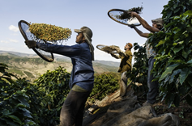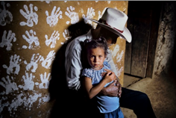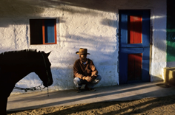

About Lavazza

The Lavazza story is the story of a family and its business. It is a typical Italian story, but the sometime a unique one, because it stems from the vision of Luigi Lavazza: a pioneer who believed in constant improvement and innovation. Luigi Lavazza’s vision, over 120 years ago, knew no boundaries. Established in 1895 in Turin, the Italian roaster has been owned by the Lavazza family for four generations.
The Group currently operates in more than 90 countries through subsidiaries and employs a total of 3,000 people with a turnover of more than €1.4 billion – financial results 2015. Lavazza invented the concept of blending — or in other words the art of combining different types of coffee from different geographical areas — something that continues to be a distinctive feature of most products today.
The company also has over 25 years of experience in the production and sale of portioned coffee systems and products. It was the first Italian business to offer capsule espresso systems. Lavazza operates in all business segments: at home, away-from-home and office coffee service, always with a focus on innovation in consumption technologies and systems.
Lavazza has been able to develop its brand awareness through important partnerships perfectly in tune with its brand internationalisation strategy, such as those in the world of sport with the Grand Slam tennis tournaments, and those in fields of art and culture with prestigious institutions, including the Guggenheim Museum in New York, the Peggy Guggenheim and MUVE (Fondazione Musei Civici Veneziani) in Venice, the Hermitage Museum in Saint Petersburg, MUDEC in Milan, as well as Camera (Centro Italiano per la Fotografia), the Merz Foundation and Circolo dei Lettori in Turin.

