THE NEW LAVAZZA A MODO MIO MILK FROTHER “MilkUp” WINS THE iF DESIGN AWARD 2017 FOR THE KITCHEN CATEGORY
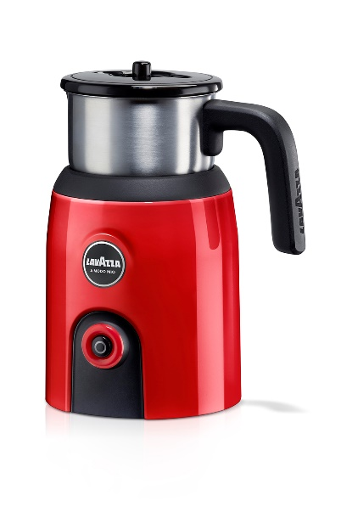
Munich, Germany (10 March 2017) – Lavazza, the world’s sixth largest coffee roaster, has won an iF DESIGN AWARD, a world-renowned design prize, in the “Product” discipline and more specifically within the “Kitchen” category for its product Lavazza A Modo Mio MilkUp. The award is conferred each year by Germany’s oldest independent design organization, Hannover-based iF International Forum Design GmbH.
MilkUp is an induction milk frother that has received this prestigious accolade from a 58-member jury, made up of independent experts from all over the world who evaluate different aspects of each product presented. The competition was intense: over 5,500 entries were submitted from 59 countries in hopes of receiving the seal of quality.
MilkUp, belongs to the Lavazza A Modo Mio range and is a good example of the new direction of Lavazza products: indeed it was designed completely in-house Lavazza design team. The design language is composed of bold, colorful and simple elements with high-quality surfacing. The external shell of this induction-based frother has a prominent color split that puts emphasis on the button. The rear ventilation slots pick up on the horizontal theme that is so important for Lavazza products. The vessel is made from INOX and can be easily cleaned. It has an ergonomic handle, and the whisk has a dedicated storage area on top of the lid.

MilkUp also offers:
Multiple Features: It warms, blends and froths the milk, for either hot or cold drinks.
Efficient Technology: Magnetic induction heating technology gives consumers quiet, efficient milk preparation.
Maximum convenience: All removable parts are dishwasher safe.
Great elegance: Italian design which guarantees high-quality materials and a colorful modern and stylish look to add a special touch to any kitchen.

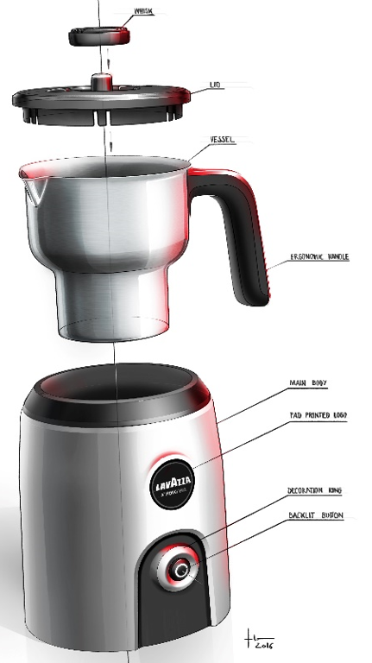

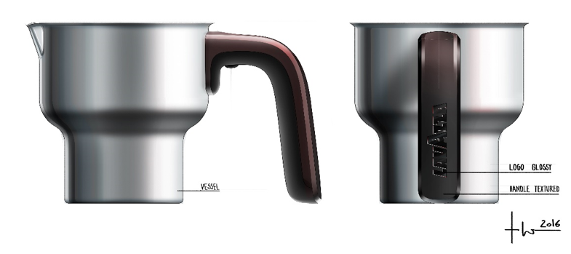

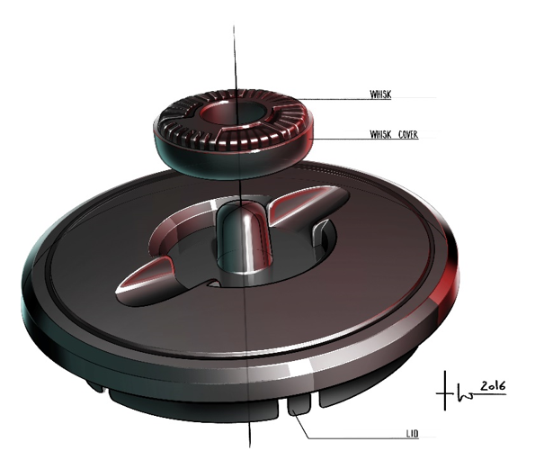

About Lavazza
Established in Turin in 1895, Lavazza is an Italian coffee producer owned by the family of the same name for four generations. The world’s sixth ranking coffee roaster, today the Group has operations in more than 90 countries, through associated companies and distributors, and exports 53% of production. After the acquisition of Carte Noire, Lavazza employs about three thousand people and has a turnover of 1,473 million euros (2015 financial statements).
Lavazza started out life by inventing the concept of coffee blending, or the art of combining different varieties of coffee from different geographical areas, in a process that remains a feature of most of the company’s products. The company also has a tradition stretching back over 25 years in the production and marketing of portioned coffee systems and products and is Italy’s leading player in the espresso capsule system segment, with operations in all business areas: home, away from home and office, with a focus, as always, on innovative technology and consumption systems.

